StratMLPart3

Version: 3.0

Data Dictionary

November 04, 2012



Your Source for XML Tools and Implementation Support

Table of Contents
Table of Contents 2
Introduction 4
Drybridge Facilitator 4
Drybridge Consulting 4
Schema Information 6
Namespace Information 6
Schema Information 6
Data Dictionary: Drybridge Documentation Facilitator 7
Acronym 7
ActualResult 7
AdministrativeInformation 8
Authority 9
Categorization 9
Category 10
Competency 10
CompetencyTypeType [attribute] 11
Criticality [attribute] 11
Description 11
DocumentType [attribute] 11
DrivingForce 12
EconomicFactor 13
EmailAddress 14
EndDate [attribute] 14
EndTime [attribute] 14
EnvironmentalFactor 15
FiveLevelType 16
FunctionType 16
GivenName 16
Goal 17
Identifier 18
Impact [attribute] 18
InhibitingOrEnabling [attribute] 18
InternalOrExternal [attribute] 19
Keyness [attribute] 19
Language [attribute] 19
LegalFactor 20
ManagementChallenge 21
MeasurementDimension 21
MeasurementInstance 22
Mission 22
Name 23
NameDescription 23
NumberOfUnits 24
Objective 24
Opportunity 25
Organization 26
Other [attribute] 27
OtherInformation 27
PerformanceIndicator 28
PerformanceIndicatorType [attribute] 29
PerformancePlanOrReport 30
PerformerOrBeneficiary [attribute] 32
PESTLE 32
PhoneNumber 33
Place 33
PointOfContact 34
PoliticalFactor 35
Priority [attribute] 36
Probability [attribute] 36
PublicationDate [attribute] 36
RASCI [attribute] 36
RatingType 37
Referent 38
Relationship 38
RelationshipType [attribute] 39
RoleType 39
SequenceIndicator 40
SevenLevelType 40
SocialFactor 40
Source 41
SpecialType 41
Stakeholder 42
StakeholderType 43
StakeholderTypeType [attribute] 44
StartDate [attribute] 44
StartTime [attribute] 44
StrategyFramework 44
Strength 45
Submitter 46
SuccessFactor 47
Surname 47
SWOT 48
TargetResult 49
TechnologicalFactor 50
TenLevelType 51
Threat 52
ThreeLevelType 53
TwoLevelType 53
UnitOfMeasurement 53
Value 53
ValueChainStage [attribute] 54
ValueProposition 54
Vision 54
Weakness 55
WebAddress 56
Weighting [attribute] 56
Schema Level Documentation 57
StratMLPart3.xsd 57

Introduction

Drybridge Facilitator
The Drybridge Facilitator is a product suite that dramatically simplifies the process of documenting and implementing schema solutions. The Facilitator is available as a local installation, as a hosted web service, or as a turnkey solution. The local installation is available in a demo mode, an ideal environment for you to evaluate the Facilitator's benefits. A document that contains this explanation has either been produced using the demo version or by someone who has been kind enough to help broaden the acceptance of the Drybridge Facilitator, in either case, "Thank you!"
There are several aspects to the Drybridge Facilitator:
- The Documentation Module produces powerful documentation for schemas and schema subsets. The documentation module allows you to create message oriented documentation (for a given root element) or a comprehensive data dictionary for all messages in your environment. Documentation can be produced based on the standard schema or based on modifications that you have made via the Schema Subset Module..
- The Schema Subset Module facilitates the creation of schema subsets that meet your specific business requirements. Easier to use and more powerful than typical XML redefinition, extension, and restriction approaches the subset module helps you to create and coordinate the use of schema subsets with your trading partners while retaining compliance with the underlying schema.
The Drybridge Facilitator simplifies the process of implementing schema solutions by allowing you to easily discuss, update, and annotate your schema and by generating annotated documentation and schema that strictly define your decisions making your development process easier. You can base your documentation on schema annotations included in the base schema and then add your own comments to the documentation.

Drybridge Consulting
Drybridge Consulting offers products and services that make it possible for companies to rapidly deploy connections between trading partners. These services allow our clients to enjoy the cost benefits of short implementation times, easy updates, and reusable code. Drybridge provides the following business integration services:
- XML message design, development, documentation, and deployment
- XML tools and stylesheet development
- Scalable, industrial-strength integration solutions
- Secure, error-free, and rapid information flow
In other words, Drybridge Consulting helps you to improve the efficiency of your business processes resulting in an improved bottom line. When you see a business process flowchart, think of Drybridge technologies. Think of the nature of the connection. Is it:
- Internal or External
- Business-to-Business or Business-to-Consumer
- Manual or Automated
- Working Correctly... or Broken
Regardless, Drybridge Consulting has the expertise to help you!

Schema Information

Namespace Information
The schemas referenced in this data dictionary use the following namespace prefixes and associated namespaces.
- [blank] http://www.stratml.net/PerformancePlanOrReport
- stratml http://www.stratml.net/PerformancePlanOrReport
- xsd http://www.w3.org/2001/XMLSchema

Schema Information
The following schema files were used in the preparation of this data dictionary.
StratMLPart3.xsd
- Path Name: file:///Z:/XML Standards/xml.gov/StratML/Part 3+/20121101/StratMLPart3.xsd
- Target Namespace: http://www.stratml.net/PerformancePlanOrReport

Data Dictionary: Drybridge Documentation Facilitator

Acronym
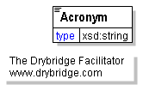
An abbreviation of a proper name usually composed of the first letters of each word in the name.

ActualResult
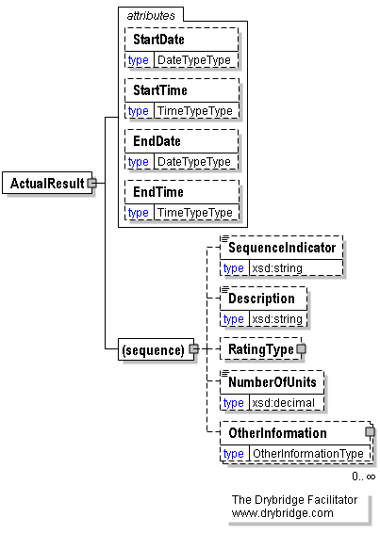
A measurable result achieved on or before a specified date.
StartDate [attribute]
StartDate is optional. A single instance might exist.
The year, month and day the element with which it is associated is scheduled to begin.
StartTime [attribute]
StartTime is optional. A single instance might exist.
The hour, minute and second the element with which it is associated is scheduled to begin.
EndDate [attribute]
EndDate is optional. A single instance might exist.
The year, month, and day the element with which it is associated is projected to cease, if it is not subsequently extended.
EndTime [attribute]
EndTime is optional. A single instance might exist.
The hour, minute, and second the element with which it is associated is projected to cease, if it is not subsequently extended. Typically the end of a calendar or fiscal year.
(sequence)
The sequence of items below is mandatory. A single instance is required.
SequenceIndicator
SequenceIndicator is optional. A single instance might exist.
An alphanumeric identifier applied to an element to designate its order in a series.
Description
Description is optional. A single instance might exist.
A sentence or short paragraph defining and explaining a concept.
RatingType
RatingType is optional. A single instance might exist.
A multi-level scale by which the quality of an actual result may be evaluated in relation to the desired target result.
NumberOfUnits
NumberOfUnits is optional. A single instance might exist.
A numeric value (number) associated with a type of measurement.
OtherInformation
OtherInformation is optional. Multiple instances might exist.
Additional explanation or guidance that is not expressly addressed in other elements of the schema.

AdministrativeInformation
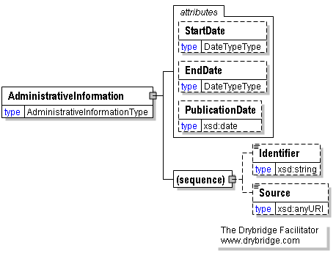
Information that is not essential to the content of plans or reports but is useful for managing them.
StartDate [attribute]
StartDate is optional. A single instance might exist.
The year, month and day the element with which it is associated is scheduled to begin.
EndDate [attribute]
EndDate is optional. A single instance might exist.
The year, month, and day the element with which it is associated is projected to cease, if it is not subsequently extended.
PublicationDate [attribute]
PublicationDate is optional. A single instance might exist.
The day, month, and year a plan, report, or an individual objective statement was published in its current form.
(sequence)
The sequence of items below is mandatory. A single instance is required.
Identifier
Identifier is optional. A single instance might exist.
A string of alphanumeric characters by which the information contained within an element is distinguished from other versions of the same information as well as information contained in other instances of the same element.
Source
Source is optional. A single instance might exist.
The Web address (URL) for the authoritative source of the information to which it refers.

Authority
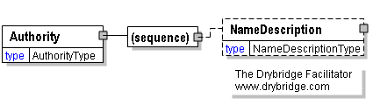
An accepted source of power to compel compliance.
(sequence)
The sequence of items below is mandatory. A single instance is required.
NameDescription
NameDescription is optional. A single instance might exist.
A complex element comprised of name, acronym, description, sequence indicator, identifier, and Web address.

Categorization
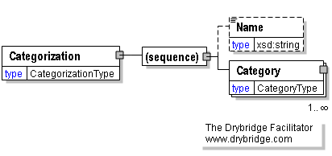
The application of terms from a controlled vocabulary to distinguish items from each other based upon their characteristics.
(sequence)
The sequence of items below is mandatory. A single instance is required.
Name
Name is optional. A single instance might exist.
A word or short phrase intended to identify a concept within the context in which is it being applied.
Category
Category is mandatory. One instance is required, multiple instances might exist.
The term selected from a controlled vocabulary in order to distinguish an item from others in its set.

Category
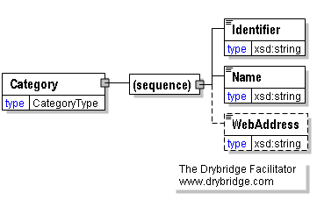
The term selected from a controlled vocabulary in order to distinguish an item from others in its set.
(sequence)
The sequence of items below is mandatory. A single instance is required.
Identifier
Identifier is mandatory. A single instance is required.
A string of alphanumeric characters by which the information contained within an element is distinguished from other versions of the same information as well as information contained in other instances of the same element.
Name
Name is mandatory. A single instance is required.
A word or short phrase intended to identify a concept within the context in which is it being applied.
WebAddress
WebAddress is optional. A single instance might exist.
The URL where the authoritative source or additional information can be found.

Competency
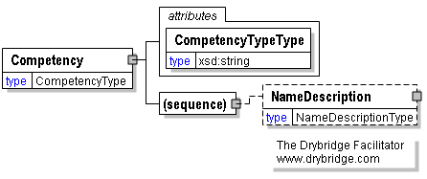
A capability that is unique to the organization, difficult for competitors to duplicate, can be leveraged broadly in multiple products or services, and contributes perceived value to beneficiary stakeholders.
CompetencyTypeType [attribute]
CompetencyTypeType is mandatory. A single instance is required.
An attribute enabling the designation of competencies as being one of three types.
Refer to CompetencyTypeType definition for any enumerations.
(sequence)
The sequence of items below is mandatory. A single instance is required.
NameDescription
NameDescription is optional. A single instance might exist.
A complex element comprised of name, acronym, description, sequence indicator, identifier, and Web address.

CompetencyTypeType [attribute]
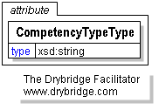
An attribute enabling the designation of competencies as being one of three types.
This item is restricted to the following list.
Core
Supporting
Ancillary

Criticality [attribute]
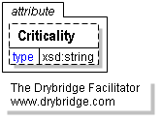
An attribute enabling the designation of success factors as being of one of two types based upon relative importance.
This item is restricted to the following list.
Critical
Contributory

Description
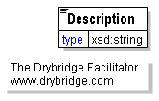
A sentence or short paragraph defining and explaining a concept.

DocumentType [attribute]
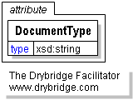
An attribute indicating whether the document is a strategic plan, a performance plan, or a performance report.
This item is restricted to the following list.
Strategic_Plan
Performance_Plan
Performance_Report

DrivingForce
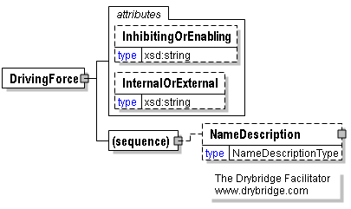
A dynamic that may powerfully influence the achievement of goals.
InhibitingOrEnabling [attribute]
InhibitingOrEnabling is optional. A single instance might exist.
An attribute enabling the designation of driving forces as being supportive or in opposition to the achievement of goals.
Refer to InhibitingOrEnabling definition for any enumerations.
InternalOrExternal [attribute]
InternalOrExternal is optional. A single instance might exist.
An attribute enabling the designation of success factors and driving forces as being within or outside of the direct control of the organization compiling the plan or report.
Refer to InternalOrExternal definition for any enumerations.
(sequence)
The sequence of items below is mandatory. A single instance is required.
NameDescription
NameDescription is optional. A single instance might exist.
A complex element comprised of name, acronym, description, sequence indicator, identifier, and Web address.

EconomicFactor
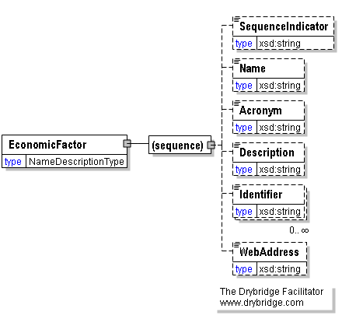
A condition in the economy that may affect the achievement of a goal.
(sequence)
The sequence of items below is mandatory. A single instance is required.
SequenceIndicator
SequenceIndicator is optional. A single instance might exist.
An alphanumeric identifier applied to an element to designate its order in a series.
Name
Name is optional. A single instance might exist.
A word or short phrase intended to identify a concept within the context in which is it being applied.
Acronym
Acronym is optional. A single instance might exist.
An abbreviation of a proper name usually composed of the first letters of each word in the name.
Description
Description is optional. A single instance might exist.
A sentence or short paragraph defining and explaining a concept.
Identifier
Identifier is optional. Multiple instances might exist.
A string of alphanumeric characters by which the information contained within an element is distinguished from other versions of the same information as well as information contained in other instances of the same element.
WebAddress
WebAddress is optional. A single instance might exist.
The URL where the authoritative source or additional information can be found.

EmailAddress
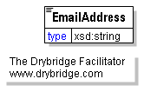
The E-mail address of a person or office.

EndDate [attribute]
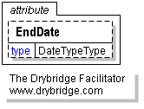
The year, month, and day the element with which it is associated is projected to cease, if it is not subsequently extended.

EndTime [attribute]
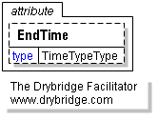
The hour, minute, and second the element with which it is associated is projected to cease, if it is not subsequently extended. Typically the end of a calendar or fiscal year.

EnvironmentalFactor
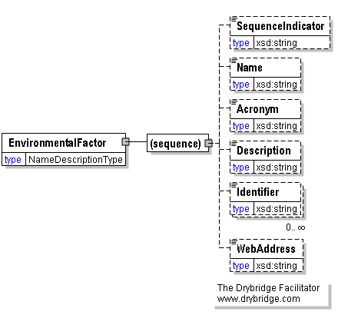
A condition in the environment that may affect the achievement of a goal.
(sequence)
The sequence of items below is mandatory. A single instance is required.
SequenceIndicator
SequenceIndicator is optional. A single instance might exist.
An alphanumeric identifier applied to an element to designate its order in a series.
Name
Name is optional. A single instance might exist.
A word or short phrase intended to identify a concept within the context in which is it being applied.
Acronym
Acronym is optional. A single instance might exist.
An abbreviation of a proper name usually composed of the first letters of each word in the name.
Description
Description is optional. A single instance might exist.
A sentence or short paragraph defining and explaining a concept.
Identifier
Identifier is optional. Multiple instances might exist.
A string of alphanumeric characters by which the information contained within an element is distinguished from other versions of the same information as well as information contained in other instances of the same element.
WebAddress
WebAddress is optional. A single instance might exist.
The URL where the authoritative source or additional information can be found.

FiveLevelType
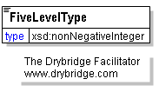
A subjective rating scale comprised of five levels.
This item is restricted to the following list.
1
2
3
4
5

FunctionType
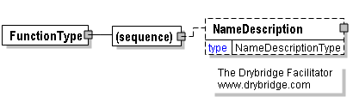
An ongoing activity conducted by an organization in support of its mission.
(sequence)
The sequence of items below is mandatory. A single instance is required.
NameDescription
NameDescription is optional. A single instance might exist.
A complex element comprised of name, acronym, description, sequence indicator, identifier, and Web address.

GivenName
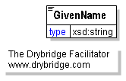
The given name of the person submitting the plan or report.

Goal
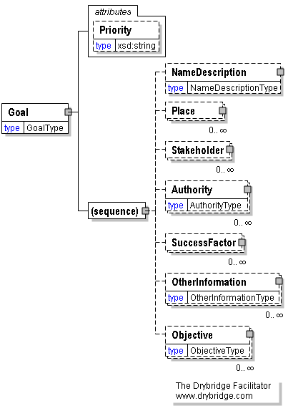
A relatively broad statement of intended results to be achieved over more than one resource allocation and performance measurement cycle.
Supports Mission.
Priority [attribute]
Priority is optional. A single instance might exist.
An attribute enabling the designation of goals as being of one of three qualitative degrees of importance.
Refer to Priority definition for any enumerations.
(sequence)
The sequence of items below is mandatory. A single instance is required.
NameDescription
NameDescription is optional. A single instance might exist.
A complex element comprised of name, acronym, description, sequence indicator, identifier, and Web address.
Place
Place is optional. Multiple instances might exist.
The named geographical area to which a goal applies.
Stakeholder
Stakeholder is optional. Multiple instances might exist.
An individual whose interests may be affected by or whose action may be required to achieve a goal or objective.
Authority
Authority is optional. Multiple instances might exist.
An accepted source of power to compel compliance.
SuccessFactor
SuccessFactor is optional. Multiple instances might exist.
A condition that contributes to the achievement of a goal.
OtherInformation
OtherInformation is optional. Multiple instances might exist.
Additional explanation or guidance that is not expressly addressed in other elements of the schema.
Objective
Objective is optional. Multiple instances might exist.
A target level of results against which achievement is to be measured within a single resource allocation and performance execution cycle.
Supports Goal.

Identifier
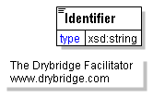
A string of alphanumeric characters by which the information contained within an element is distinguished from other versions of the same information as well as information contained in other instances of the same element.

Impact [attribute]
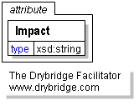
An attribute documenting the scope of the effect of a management challenge, if were to occur.
This item is restricted to the following list.
To_Be_Determined
High
Medium
Low

InhibitingOrEnabling [attribute]
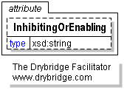
An attribute enabling the designation of driving forces as being supportive or in opposition to the achievement of goals.
This item is restricted to the following list.
Enabling
Inhibiting

InternalOrExternal [attribute]
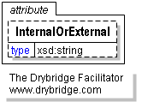
An attribute enabling the designation of success factors and driving forces as being within or outside of the direct control of the organization compiling the plan or report.
This item is restricted to the following list.
Internal
External

Keyness [attribute]
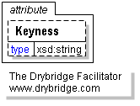
An attribute enabling designation of the importance of a performance indicator, such as for monitoring by the top managers of the organization.
This item is restricted to the following list.
To_Be_Determined
Key
Secondary
Ancillary

Language [attribute]
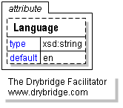
The ISO code for the language of the text of the document.
This item is restricted to the following list.
en
es
de
fr
it
ja
pt
ru
zh

LegalFactor
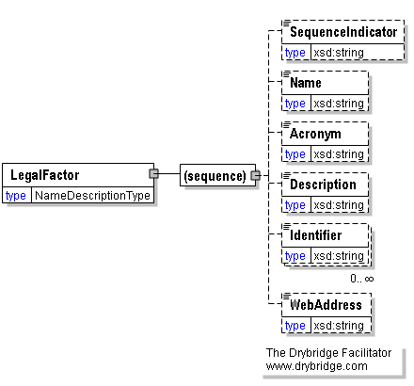
A matter of law that may affect the achievement of a goal.
(sequence)
The sequence of items below is mandatory. A single instance is required.
SequenceIndicator
SequenceIndicator is optional. A single instance might exist.
An alphanumeric identifier applied to an element to designate its order in a series.
Name
Name is optional. A single instance might exist.
A word or short phrase intended to identify a concept within the context in which is it being applied.
Acronym
Acronym is optional. A single instance might exist.
An abbreviation of a proper name usually composed of the first letters of each word in the name.
Description
Description is optional. A single instance might exist.
A sentence or short paragraph defining and explaining a concept.
Identifier
Identifier is optional. Multiple instances might exist.
A string of alphanumeric characters by which the information contained within an element is distinguished from other versions of the same information as well as information contained in other instances of the same element.
WebAddress
WebAddress is optional. A single instance might exist.
The URL where the authoritative source or additional information can be found.

ManagementChallenge
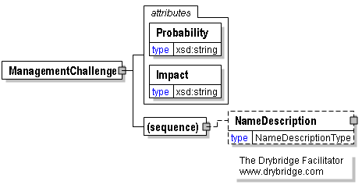
A relatively difficult issue to be addressed or obstacle to be overcome in order to achieve an objective.
Probability [attribute]
Probability is mandatory. A single instance is required.
An attribute documenting the likelihood that a management challenge will occur.
Refer to Probability definition for any enumerations.
Impact [attribute]
Impact is mandatory. A single instance is required.
An attribute documenting the scope of the effect of a management challenge, if were to occur.
Refer to Impact definition for any enumerations.
(sequence)
The sequence of items below is mandatory. A single instance is required.
NameDescription
NameDescription is optional. A single instance might exist.
A complex element comprised of name, acronym, description, sequence indicator, identifier, and Web address.

MeasurementDimension
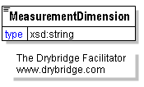
The aspect of reality to be measured.

MeasurementInstance
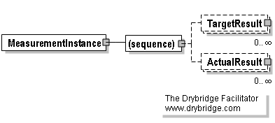
A measurement at a point in time.
(sequence)
The sequence of items below is mandatory. A single instance is required.
TargetResult
TargetResult is optional. Multiple instances might exist.
A measurable result to be achieved on or before a specified date.
ActualResult
ActualResult is optional. Multiple instances might exist.
A measurable result achieved on or before a specified date.

Mission
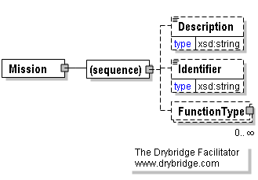
A brief description of the basic purpose of the organization.
(sequence)
The sequence of items below is mandatory. A single instance is required.
Description
Description is optional. A single instance might exist.
A sentence or short paragraph defining and explaining a concept.
Identifier
Identifier is optional. A single instance might exist.
A string of alphanumeric characters by which the information contained within an element is distinguished from other versions of the same information as well as information contained in other instances of the same element.
FunctionType
FunctionType is optional. Multiple instances might exist.
An ongoing activity conducted by an organization in support of its mission.

Name
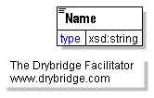
A word or short phrase intended to identify a concept within the context in which is it being applied.

NameDescription
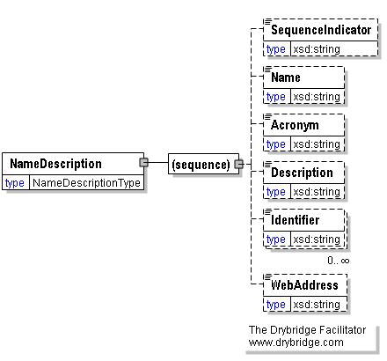
A complex element comprised of name, acronym, description, sequence indicator, identifier, and Web address.
(sequence)
The sequence of items below is mandatory. A single instance is required.
SequenceIndicator
SequenceIndicator is optional. A single instance might exist.
An alphanumeric identifier applied to an element to designate its order in a series.
Name
Name is optional. A single instance might exist.
A word or short phrase intended to identify a concept within the context in which is it being applied.
Acronym
Acronym is optional. A single instance might exist.
An abbreviation of a proper name usually composed of the first letters of each word in the name.
Description
Description is optional. A single instance might exist.
A sentence or short paragraph defining and explaining a concept.
Identifier
Identifier is optional. Multiple instances might exist.
A string of alphanumeric characters by which the information contained within an element is distinguished from other versions of the same information as well as information contained in other instances of the same element.
WebAddress
WebAddress is optional. A single instance might exist.
The URL where the authoritative source or additional information can be found.

NumberOfUnits
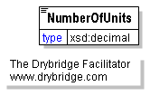
A numeric value (number) associated with a type of measurement.

Objective
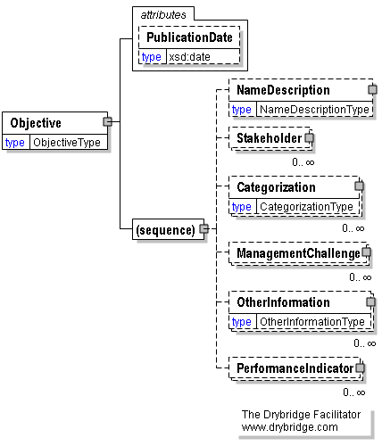
A target level of results against which achievement is to be measured within a single resource allocation and performance execution cycle.
Supports Goal.
PublicationDate [attribute]
PublicationDate is optional. A single instance might exist.
The day, month, and year a plan, report, or an individual objective statement was published in its current form.
(sequence)
The sequence of items below is mandatory. A single instance is required.
NameDescription
NameDescription is optional. A single instance might exist.
A complex element comprised of name, acronym, description, sequence indicator, identifier, and Web address.
Stakeholder
Stakeholder is optional. Multiple instances might exist.
An individual whose interests may be affected by or whose action may be required to achieve a goal or objective.
Categorization
Categorization is optional. Multiple instances might exist.
The application of terms from a controlled vocabulary to distinguish items from each other based upon their characteristics.
ManagementChallenge
ManagementChallenge is optional. Multiple instances might exist.
A relatively difficult issue to be addressed or obstacle to be overcome in order to achieve an objective.
OtherInformation
OtherInformation is optional. Multiple instances might exist.
Additional explanation or guidance that is not expressly addressed in other elements of the schema.
PerformanceIndicator
PerformanceIndicator is optional. Multiple instances might exist.
A measurement dimension, unit of measurement, and measurement instance specifying target and actual results, e.g., of inputs applied, outputs produced, processes conducted, and outcomes realized.

Opportunity
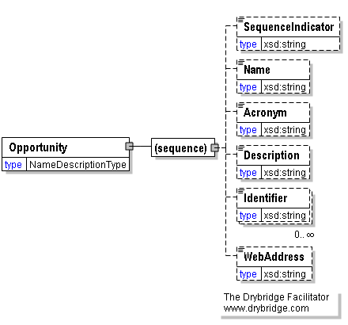
A condition upon which an organization may wish to capitalize to benefit its stakeholders.
(sequence)
The sequence of items below is mandatory. A single instance is required.
SequenceIndicator
SequenceIndicator is optional. A single instance might exist.
An alphanumeric identifier applied to an element to designate its order in a series.
Name
Name is optional. A single instance might exist.
A word or short phrase intended to identify a concept within the context in which is it being applied.
Acronym
Acronym is optional. A single instance might exist.
An abbreviation of a proper name usually composed of the first letters of each word in the name.
Description
Description is optional. A single instance might exist.
A sentence or short paragraph defining and explaining a concept.
Identifier
Identifier is optional. Multiple instances might exist.
A string of alphanumeric characters by which the information contained within an element is distinguished from other versions of the same information as well as information contained in other instances of the same element.
WebAddress
WebAddress is optional. A single instance might exist.
The URL where the authoritative source or additional information can be found.

Organization
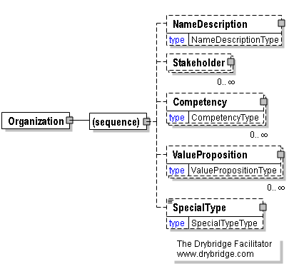
The legal or logical entity to which the plan or report applies.
(sequence)
The sequence of items below is mandatory. A single instance is required.
NameDescription
NameDescription is optional. A single instance might exist.
A complex element comprised of name, acronym, description, sequence indicator, identifier, and Web address.
Stakeholder
Stakeholder is optional. Multiple instances might exist.
An individual whose interests may be affected by or whose action may be required to achieve a goal or objective.
Competency
Competency is optional. Multiple instances might exist.
A capability that is unique to the organization, difficult for competitors to duplicate, can be leveraged broadly in multiple products or services, and contributes perceived value to beneficiary stakeholders.
ValueProposition
ValueProposition is optional. Multiple instances might exist.
A statement of value to be delivered by an organization and a belief on the part of intended beneficiary stakeholders that such value will be realized.
SpecialType
SpecialType is optional. A single instance might exist.
An element enabling the naming of other strategic planning and performance reporting entities that are not commonly considered to be organizations and not yet included in the controlled vocabulary of special types of organizations in the context of the StratML standard.
Such entities may be candidates for inclusion in the controlled vocabulary for special types of organizations in subsequent releases of the StratML standard.
The "other" attribute may be used to indicate that the name of the type of planning entity not yet listed in the controlled vocabulary for special types of organizations in the context of the StratML standard.
Refer to SpecialType definition for any enumerations.

Other [attribute]
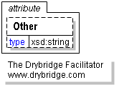
An attribute enabling the designation of an organization as being of a special type not yet included in the enumerated listing of special types not commonly considered to be organizations.

OtherInformation
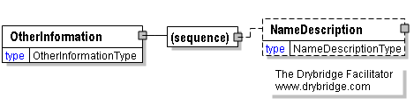
Additional explanation or guidance that is not expressly addressed in other elements of the schema.
(sequence)
The sequence of items below is mandatory. A single instance is required.
NameDescription
NameDescription is optional. A single instance might exist.
A complex element comprised of name, acronym, description, sequence indicator, identifier, and Web address.

PerformanceIndicator
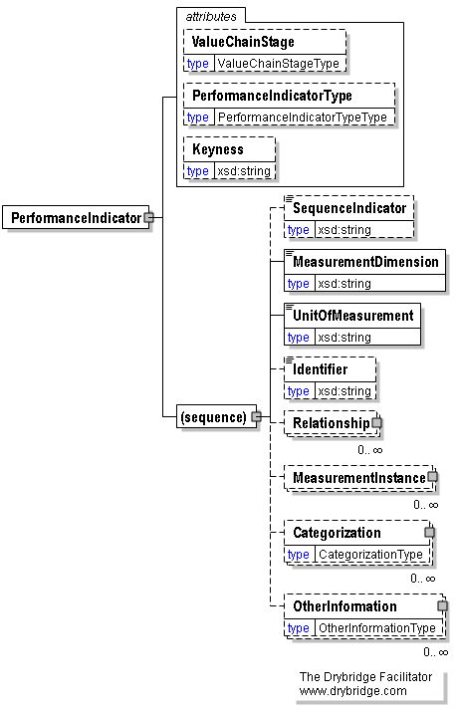
A measurement dimension, unit of measurement, and measurement instance specifying target and actual results, e.g., of inputs applied, outputs produced, processes conducted, and outcomes realized.
ValueChainStage [attribute]
ValueChainStage is optional. A single instance might exist.
An element enabling the designation of a performance indicator as being of one of five enumerated types. When combined in serial order, the five types comprise the full chain for the delivery of value to stakeholders.
Refer to ValueChainStage definition for any enumerations.
PerformanceIndicatorType [attribute]
PerformanceIndicatorType is optional. A single instance might exist.
An attribute enabling the designation of a performance indicator as being either subject to objective measurement or based upon a subjective determination made by an individual or group of people empowered to render such judgment.
Refer to PerformanceIndicatorType definition for any enumerations.
Keyness [attribute]
Keyness is optional. A single instance might exist.
An attribute enabling designation of the importance of a performance indicator, such as for monitoring by the top managers of the organization.
Refer to Keyness definition for any enumerations.
(sequence)
The sequence of items below is mandatory. A single instance is required.
SequenceIndicator
SequenceIndicator is optional. A single instance might exist.
An alphanumeric identifier applied to an element to designate its order in a series.
MeasurementDimension
MeasurementDimension is mandatory. A single instance is required.
The aspect of reality to be measured.
UnitOfMeasurement
UnitOfMeasurement is mandatory. A single instance is required.
The scale by which measurements are divided into increments.
Identifier
Identifier is optional. A single instance might exist.
A string of alphanumeric characters by which the information contained within an element is distinguished from other versions of the same information as well as information contained in other instances of the same element.
Relationship
Relationship is optional. Multiple instances might exist.
A conceptual connection between two elements that have Identifiers.
MeasurementInstance
MeasurementInstance is optional. Multiple instances might exist.
A measurement at a point in time.
Categorization
Categorization is optional. Multiple instances might exist.
The application of terms from a controlled vocabulary to distinguish items from each other based upon their characteristics.
OtherInformation
OtherInformation is optional. Multiple instances might exist.
Additional explanation or guidance that is not expressly addressed in other elements of the schema.

PerformanceIndicatorType [attribute]
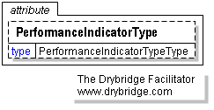
An attribute enabling the designation of a performance indicator as being either subject to objective measurement or based upon a subjective determination made by an individual or group of people empowered to render such judgment.
This item is restricted to the following list.
Quantitative
Qualitative

PerformancePlanOrReport
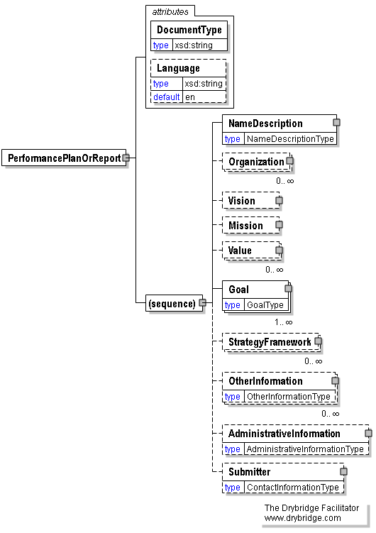
A document identifying inputs and processes required to accomplish objectives and establishing metrics by which progress will be assessed within a single budgetary planning and resource allocation cycle.
DocumentType [attribute]
DocumentType is mandatory. A single instance is required.
An attribute indicating whether the document is a strategic plan, a performance plan, or a performance report.
Refer to DocumentType definition for any enumerations.
Language [attribute]
Language is optional. A single instance might exist.
The ISO code for the language of the text of the document.
Refer to Language definition for any enumerations.
(sequence)
The sequence of items below is mandatory. A single instance is required.
NameDescription
NameDescription is mandatory. A single instance is required.
A complex element comprised of name, acronym, description, sequence indicator, identifier, and Web address.
Organization
Organization is optional. Multiple instances might exist.
The legal or logical entity to which the plan or report applies.
Vision
Vision is optional. A single instance might exist.
A concise and inspirational statement implicitly relating an organization's purpose to its values, thus motivating its actions toward a future state it strives to achieve.
Mission
Mission is optional. A single instance might exist.
A brief description of the basic purpose of the organization.
Value
Value is optional. Multiple instances might exist.
A principle that is important and helps to define the essential character of the organization.
Goal
Goal is mandatory. One instance is required, multiple instances might exist.
A relatively broad statement of intended results to be achieved over more than one resource allocation and performance measurement cycle.
Supports Mission.
StrategyFramework
StrategyFramework is optional. Multiple instances might exist.
The methodology used to determine goals and objectives.
OtherInformation
OtherInformation is optional. Multiple instances might exist.
Additional explanation or guidance that is not expressly addressed in other elements of the schema.
AdministrativeInformation
AdministrativeInformation is optional. A single instance might exist.
Information that is not essential to the content of plans or reports but is useful for managing them.
Submitter
Submitter is optional. A single instance might exist.
The person submitting the plan or report in StratML format.

PerformerOrBeneficiary [attribute]
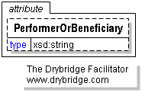
An attribute enabling designation of stakeholders as either prospective beneficiaries or performers of actions required to achieve an objective, or both performers and beneficiaries.
This item is restricted to the following list.
Performer
Beneficiary

PESTLE
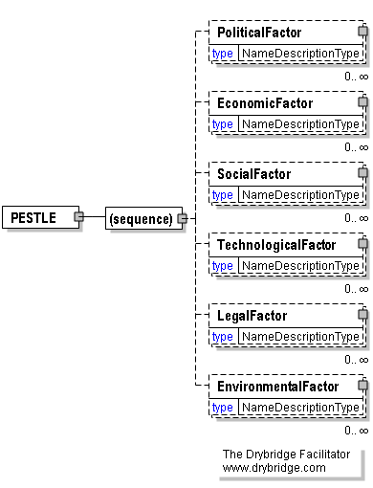
Political, economic, social, technological, legal and environmental factors.
(sequence)
The sequence of items below is mandatory. A single instance is required.
PoliticalFactor
PoliticalFactor is optional. Multiple instances might exist.
A condition influenced by politics that may affect the achievement of a goal.
EconomicFactor
EconomicFactor is optional. Multiple instances might exist.
A condition in the economy that may affect the achievement of a goal.
SocialFactor
SocialFactor is optional. Multiple instances might exist.
A condition in society that may affect the achievement of a goal.
TechnologicalFactor
TechnologicalFactor is optional. Multiple instances might exist.
A condition associated with technology that may affect the achievement of a goal.
LegalFactor
LegalFactor is optional. Multiple instances might exist.
A matter of law that may affect the achievement of a goal.
EnvironmentalFactor
EnvironmentalFactor is optional. Multiple instances might exist.
A condition in the environment that may affect the achievement of a goal.

PhoneNumber
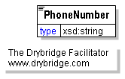
The telephone number of the person submitting the plan.

Place
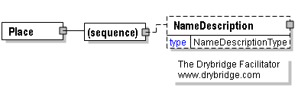
The named geographical area to which a goal applies.
(sequence)
The sequence of items below is mandatory. A single instance is required.
NameDescription
NameDescription is optional. A single instance might exist.
A complex element comprised of name, acronym, description, sequence indicator, identifier, and Web address.

PointOfContact
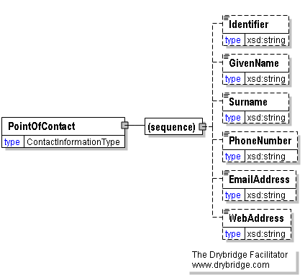
The person or office to be contacted for further information or to submit comments.
(sequence)
The sequence of items below is mandatory. A single instance is required.
Identifier
Identifier is optional. A single instance might exist.
A string of alphanumeric characters by which the information contained within an element is distinguished from other versions of the same information as well as information contained in other instances of the same element.
GivenName
GivenName is optional. A single instance might exist.
The given name of the person submitting the plan or report.
Surname
Surname is optional. A single instance might exist.
The family name of the person submitting the plan or report.
PhoneNumber
PhoneNumber is optional. A single instance might exist.
The telephone number of the person submitting the plan.
EmailAddress
EmailAddress is optional. A single instance might exist.
The E-mail address of a person or office.
WebAddress
WebAddress is optional. A single instance might exist.
The URL where the authoritative source or additional information can be found.

PoliticalFactor
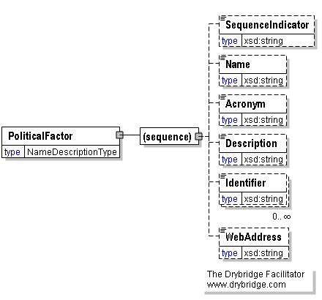
A condition influenced by politics that may affect the achievement of a goal.
(sequence)
The sequence of items below is mandatory. A single instance is required.
SequenceIndicator
SequenceIndicator is optional. A single instance might exist.
An alphanumeric identifier applied to an element to designate its order in a series.
Name
Name is optional. A single instance might exist.
A word or short phrase intended to identify a concept within the context in which is it being applied.
Acronym
Acronym is optional. A single instance might exist.
An abbreviation of a proper name usually composed of the first letters of each word in the name.
Description
Description is optional. A single instance might exist.
A sentence or short paragraph defining and explaining a concept.
Identifier
Identifier is optional. Multiple instances might exist.
A string of alphanumeric characters by which the information contained within an element is distinguished from other versions of the same information as well as information contained in other instances of the same element.
WebAddress
WebAddress is optional. A single instance might exist.
The URL where the authoritative source or additional information can be found.

Priority [attribute]
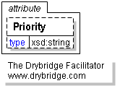
An attribute enabling the designation of goals as being of one of three qualitative degrees of importance.
This item is restricted to the following list.
To_Be_Determined
High
Medium
Low

Probability [attribute]
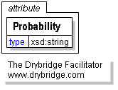
An attribute documenting the likelihood that a management challenge will occur.
This item is restricted to the following list.
To_Be_Determined
High
Medium
Low

PublicationDate [attribute]
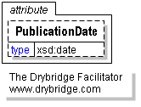
The day, month, and year a plan, report, or an individual objective statement was published in its current form.

RASCI [attribute]
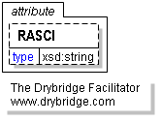
An attribute enabling the designation of a roles as being of one of five types, commonly known as RASCI.
This item is restricted to the following list.
Responsible
Accountable
Supportive
to_be_Consulted
to_be_Informed

RatingType
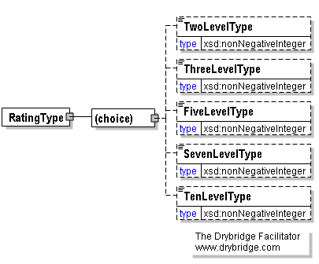
A multi-level scale by which the quality of an actual result may be evaluated in relation to the desired target result.
(choice)
[choice] is optional because of choice construct.
TwoLevelType
TwoLevelType is optional because of choice construct.
A subjective rating scale comprised of two levels.
Refer to TwoLevelType definition for any enumerations.
ThreeLevelType
ThreeLevelType is optional because of choice construct.
A subjective rating scale comprised of three levels.
Refer to ThreeLevelType definition for any enumerations.
FiveLevelType
FiveLevelType is optional because of choice construct.
A subjective rating scale comprised of five levels.
Refer to FiveLevelType definition for any enumerations.
SevenLevelType
SevenLevelType is optional because of choice construct.
A subjective rating scale comprised of seven levels.
Refer to SevenLevelType definition for any enumerations.
TenLevelType
TenLevelType is optional because of choice construct.
A subjective rating scale comprised of ten levels.
Refer to TenLevelType definition for any enumerations.

Referent
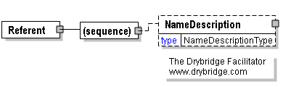
The target (object) of a designated relationship.
(sequence)
The sequence of items below is mandatory. A single instance is required.
NameDescription
NameDescription is optional. A single instance might exist.
A complex element comprised of name, acronym, description, sequence indicator, identifier, and Web address.

Relationship
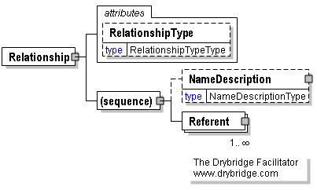
A conceptual connection between two elements that have Identifiers.
RelationshipType [attribute]
RelationshipType is optional. A single instance might exist.
An attribute enabling the designation of a relationship as being of one of three enumerated types.
Refer to RelationshipType definition for any enumerations.
(sequence)
The sequence of items below is mandatory. A single instance is required.
NameDescription
NameDescription is optional. A single instance might exist.
A complex element comprised of name, acronym, description, sequence indicator, identifier, and Web address.
Referent
Referent is mandatory. One instance is required, multiple instances might exist.
The target (object) of a designated relationship.

RelationshipType [attribute]
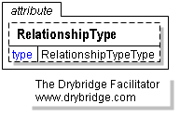
An attribute enabling the designation of a relationship as being of one of three enumerated types.
This item is restricted to the following list.
Broader_Than
Peer_To
Narrower_Than

RoleType
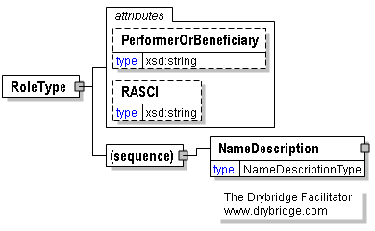
A complex element containing other elements enabling the naming, description, and categorization of different kinds of interests individuals and groups may have in the achievement of goals and objectives.
PerformerOrBeneficiary [attribute]
PerformerOrBeneficiary is optional. A single instance might exist.
An attribute enabling designation of stakeholders as either prospective beneficiaries or performers of actions required to achieve an objective, or both performers and beneficiaries.
Refer to PerformerOrBeneficiary definition for any enumerations.
RASCI [attribute]
RASCI is optional. A single instance might exist.
An attribute enabling the designation of a roles as being of one of five types, commonly known as RASCI.
Refer to RASCI definition for any enumerations.
(sequence)
The sequence of items below is mandatory. A single instance is required.
NameDescription
NameDescription is mandatory. A single instance is required.
A complex element comprised of name, acronym, description, sequence indicator, identifier, and Web address.

SequenceIndicator
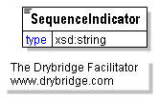
An alphanumeric identifier applied to an element to designate its order in a series.

SevenLevelType
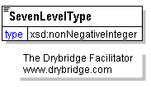
A subjective rating scale comprised of seven levels.
This item is restricted to the following list.
1
2
3
4
5
6
7

SocialFactor
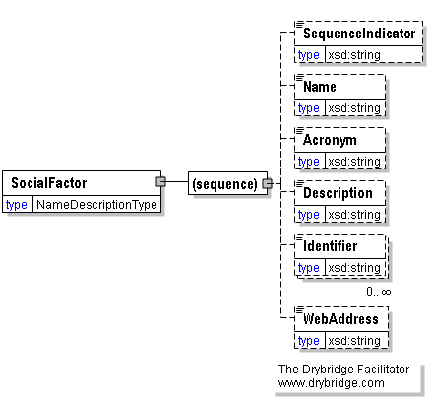
A condition in society that may affect the achievement of a goal.
(sequence)
The sequence of items below is mandatory. A single instance is required.
SequenceIndicator
SequenceIndicator is optional. A single instance might exist.
An alphanumeric identifier applied to an element to designate its order in a series.
Name
Name is optional. A single instance might exist.
A word or short phrase intended to identify a concept within the context in which is it being applied.
Acronym
Acronym is optional. A single instance might exist.
An abbreviation of a proper name usually composed of the first letters of each word in the name.
Description
Description is optional. A single instance might exist.
A sentence or short paragraph defining and explaining a concept.
Identifier
Identifier is optional. Multiple instances might exist.
A string of alphanumeric characters by which the information contained within an element is distinguished from other versions of the same information as well as information contained in other instances of the same element.
WebAddress
WebAddress is optional. A single instance might exist.
The URL where the authoritative source or additional information can be found.

Source
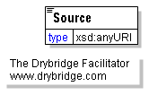
The Web address (URL) for the authoritative source of the information to which it refers.

SpecialType
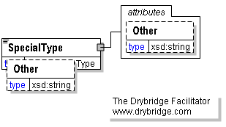
An element enabling the naming of other strategic planning and performance reporting entities that are not commonly considered to be organizations and not yet included in the controlled vocabulary of special types of organizations in the context of the StratML standard.
Such entities may be candidates for inclusion in the controlled vocabulary for special types of organizations in subsequent releases of the StratML standard.
The "other" attribute may be used to indicate that the name of the type of planning entity not yet listed in the controlled vocabulary for special types of organizations in the context of the StratML standard.
This item is restricted to the following list.
Board_of_Directors
Committee
Conference
Consortium
Cooperative
Exposition
Family
Individual
Initiative
Investment
Program
Project
Student
System
Virtual
Work_Group
Other
Other [attribute]
Other is optional. A single instance might exist.
An attribute enabling the designation of an organization as being of a special type not yet included in the enumerated listing of special types not commonly considered to be organizations.

Stakeholder
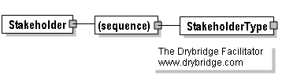
An individual whose interests may be affected by or whose action may be required to achieve a goal or objective.
(sequence)
The sequence of items below is mandatory. A single instance is required.
StakeholderType
StakeholderType is mandatory. A single instance is required.
A complex element enabling the naming and categorization of stakeholders as well as the specification of their roles and points of contact.

StakeholderType
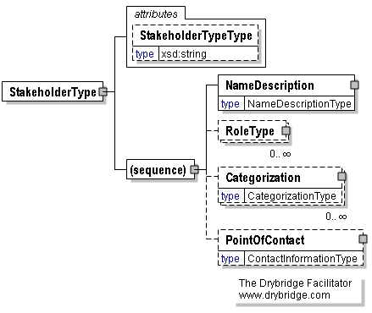
A complex element enabling the naming and categorization of stakeholders as well as the specification of their roles and points of contact.
StakeholderTypeType [attribute]
StakeholderTypeType is optional. A single instance might exist.
An attribute indicating whether the stakeholder is an individual person, an organization, or a generic group of people.
Refer to StakeholderTypeType definition for any enumerations.
(sequence)
The sequence of items below is mandatory. A single instance is required.
NameDescription
NameDescription is mandatory. A single instance is required.
A complex element comprised of name, acronym, description, sequence indicator, identifier, and Web address.
RoleType
RoleType is optional. Multiple instances might exist.
A complex element containing other elements enabling the naming, description, and categorization of different kinds of interests individuals and groups may have in the achievement of goals and objectives.
Categorization
Categorization is optional. Multiple instances might exist.
The application of terms from a controlled vocabulary to distinguish items from each other based upon their characteristics.
PointOfContact
PointOfContact is optional. A single instance might exist.
The person or office to be contacted for further information or to submit comments.

StakeholderTypeType [attribute]
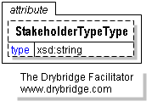
An attribute indicating whether the stakeholder is an individual person, an organization, or a generic group of people.
This item is restricted to the following list.
Person
Organization
Generic_Group

StartDate [attribute]
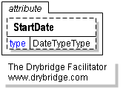
The year, month and day the element with which it is associated is scheduled to begin.

StartTime [attribute]
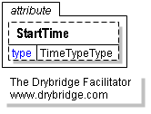
The hour, minute and second the element with which it is associated is scheduled to begin.

StrategyFramework
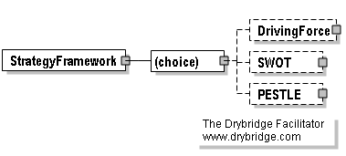
The methodology used to determine goals and objectives.
(choice)
[choice] is optional because of choice construct.
DrivingForce
DrivingForce is optional because of choice construct.
A dynamic that may powerfully influence the achievement of goals.
SWOT
SWOT is optional because of choice construct.
Strengths, weaknesses, opportunities, and threats.
PESTLE
PESTLE is optional because of choice construct.
Political, economic, social, technological, legal and environmental factors.

Strength
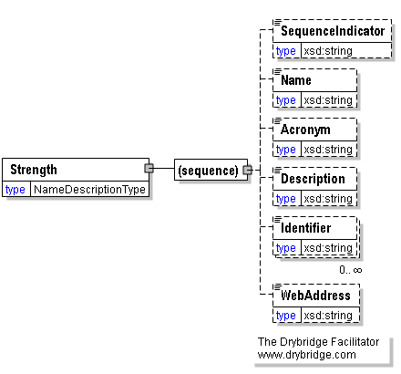
A positive aspect of an organization that may provide a competitive advantage.
(sequence)
The sequence of items below is mandatory. A single instance is required.
SequenceIndicator
SequenceIndicator is optional. A single instance might exist.
An alphanumeric identifier applied to an element to designate its order in a series.
Name
Name is optional. A single instance might exist.
A word or short phrase intended to identify a concept within the context in which is it being applied.
Acronym
Acronym is optional. A single instance might exist.
An abbreviation of a proper name usually composed of the first letters of each word in the name.
Description
Description is optional. A single instance might exist.
A sentence or short paragraph defining and explaining a concept.
Identifier
Identifier is optional. Multiple instances might exist.
A string of alphanumeric characters by which the information contained within an element is distinguished from other versions of the same information as well as information contained in other instances of the same element.
WebAddress
WebAddress is optional. A single instance might exist.
The URL where the authoritative source or additional information can be found.

Submitter
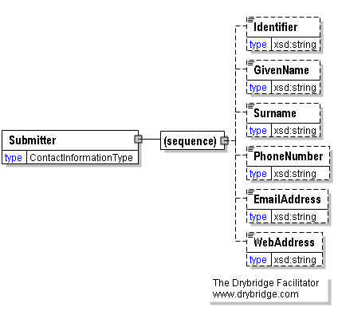
The person submitting the plan or report in StratML format.
(sequence)
The sequence of items below is mandatory. A single instance is required.
Identifier
Identifier is optional. A single instance might exist.
A string of alphanumeric characters by which the information contained within an element is distinguished from other versions of the same information as well as information contained in other instances of the same element.
GivenName
GivenName is optional. A single instance might exist.
The given name of the person submitting the plan or report.
Surname
Surname is optional. A single instance might exist.
The family name of the person submitting the plan or report.
PhoneNumber
PhoneNumber is optional. A single instance might exist.
The telephone number of the person submitting the plan.
EmailAddress
EmailAddress is optional. A single instance might exist.
The E-mail address of a person or office.
WebAddress
WebAddress is optional. A single instance might exist.
The URL where the authoritative source or additional information can be found.

SuccessFactor
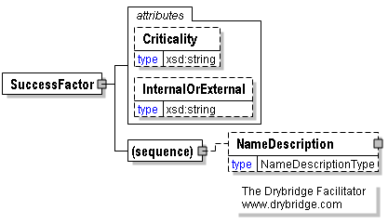
A condition that contributes to the achievement of a goal.
Criticality [attribute]
Criticality is optional. A single instance might exist.
An attribute enabling the designation of success factors as being of one of two types based upon relative importance.
Refer to Criticality definition for any enumerations.
InternalOrExternal [attribute]
InternalOrExternal is optional. A single instance might exist.
An attribute enabling the designation of success factors and driving forces as being within or outside of the direct control of the organization compiling the plan or report.
Refer to InternalOrExternal definition for any enumerations.
(sequence)
The sequence of items below is mandatory. A single instance is required.
NameDescription
NameDescription is optional. A single instance might exist.
A complex element comprised of name, acronym, description, sequence indicator, identifier, and Web address.

Surname
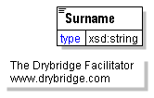
The family name of the person submitting the plan or report.

SWOT
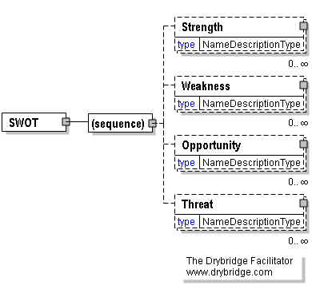
Strengths, weaknesses, opportunities, and threats.
(sequence)
The sequence of items below is mandatory. A single instance is required.
Strength
Strength is optional. Multiple instances might exist.
A positive aspect of an organization that may provide a competitive advantage.
Weakness
Weakness is optional. Multiple instances might exist.
A negative aspect of an organization that may place it at a competitive disadvantage.
Opportunity
Opportunity is optional. Multiple instances might exist.
A condition upon which an organization may wish to capitalize to benefit its stakeholders.
Threat
Threat is optional. Multiple instances might exist.
A condition that may negatively impact the achievement of a goal.

TargetResult
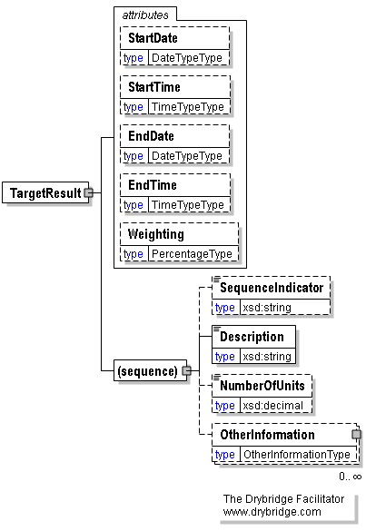
A measurable result to be achieved on or before a specified date.
StartDate [attribute]
StartDate is optional. A single instance might exist.
The year, month and day the element with which it is associated is scheduled to begin.
StartTime [attribute]
StartTime is optional. A single instance might exist.
The hour, minute and second the element with which it is associated is scheduled to begin.
EndDate [attribute]
EndDate is optional. A single instance might exist.
The year, month, and day the element with which it is associated is projected to cease, if it is not subsequently extended.
EndTime [attribute]
EndTime is optional. A single instance might exist.
The hour, minute, and second the element with which it is associated is projected to cease, if it is not subsequently extended. Typically the end of a calendar or fiscal year.
Weighting [attribute]
Weighting is optional. A single instance might exist.
An attribute enabling the designation of a performance indicator as being a certain percentage of a total performance rating score.
(sequence)
The sequence of items below is mandatory. A single instance is required.
SequenceIndicator
SequenceIndicator is optional. A single instance might exist.
An alphanumeric identifier applied to an element to designate its order in a series.
Description
Description is mandatory. A single instance is required.
A sentence or short paragraph defining and explaining a concept.
NumberOfUnits
NumberOfUnits is optional. A single instance might exist.
A numeric value (number) associated with a type of measurement.
OtherInformation
OtherInformation is optional. Multiple instances might exist.
Additional explanation or guidance that is not expressly addressed in other elements of the schema.

TechnologicalFactor
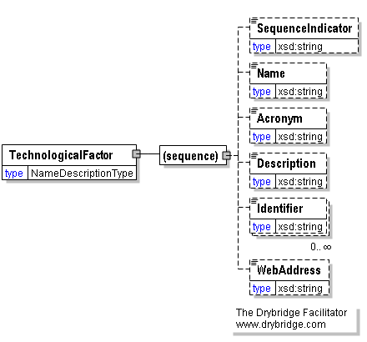
A condition associated with technology that may affect the achievement of a goal.
(sequence)
The sequence of items below is mandatory. A single instance is required.
SequenceIndicator
SequenceIndicator is optional. A single instance might exist.
An alphanumeric identifier applied to an element to designate its order in a series.
Name
Name is optional. A single instance might exist.
A word or short phrase intended to identify a concept within the context in which is it being applied.
Acronym
Acronym is optional. A single instance might exist.
An abbreviation of a proper name usually composed of the first letters of each word in the name.
Description
Description is optional. A single instance might exist.
A sentence or short paragraph defining and explaining a concept.
Identifier
Identifier is optional. Multiple instances might exist.
A string of alphanumeric characters by which the information contained within an element is distinguished from other versions of the same information as well as information contained in other instances of the same element.
WebAddress
WebAddress is optional. A single instance might exist.
The URL where the authoritative source or additional information can be found.

TenLevelType
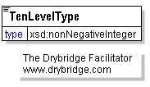
A subjective rating scale comprised of ten levels.
This item is restricted to the following list.
1
2
3
4
5
6
7
8
9
10

Threat
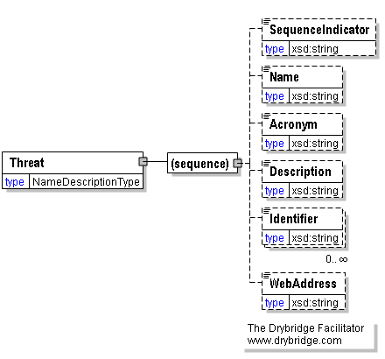
A condition that may negatively impact the achievement of a goal.
(sequence)
The sequence of items below is mandatory. A single instance is required.
SequenceIndicator
SequenceIndicator is optional. A single instance might exist.
An alphanumeric identifier applied to an element to designate its order in a series.
Name
Name is optional. A single instance might exist.
A word or short phrase intended to identify a concept within the context in which is it being applied.
Acronym
Acronym is optional. A single instance might exist.
An abbreviation of a proper name usually composed of the first letters of each word in the name.
Description
Description is optional. A single instance might exist.
A sentence or short paragraph defining and explaining a concept.
Identifier
Identifier is optional. Multiple instances might exist.
A string of alphanumeric characters by which the information contained within an element is distinguished from other versions of the same information as well as information contained in other instances of the same element.
WebAddress
WebAddress is optional. A single instance might exist.
The URL where the authoritative source or additional information can be found.

ThreeLevelType
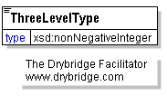
A subjective rating scale comprised of three levels.
This item is restricted to the following list.
0
1
2

TwoLevelType
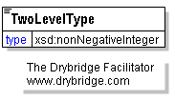
A subjective rating scale comprised of two levels.
This item is restricted to the following list.
0
1

UnitOfMeasurement
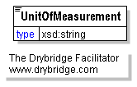
The scale by which measurements are divided into increments.

Value
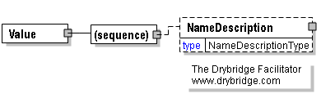
A principle that is important and helps to define the essential character of the organization.
(sequence)
The sequence of items below is mandatory. A single instance is required.
NameDescription
NameDescription is optional. A single instance might exist.
A complex element comprised of name, acronym, description, sequence indicator, identifier, and Web address.

ValueChainStage [attribute]
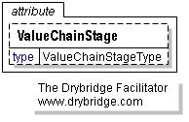
An element enabling the designation of a performance indicator as being of one of five enumerated types. When combined in serial order, the five types comprise the full chain for the delivery of value to stakeholders.
This item is restricted to the following list.
Outcome
Output_Processing
Output
Input_Processing
Input

ValueProposition
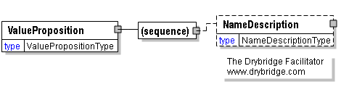
A statement of value to be delivered by an organization and a belief on the part of intended beneficiary stakeholders that such value will be realized.
(sequence)
The sequence of items below is mandatory. A single instance is required.
NameDescription
NameDescription is optional. A single instance might exist.
A complex element comprised of name, acronym, description, sequence indicator, identifier, and Web address.

Vision
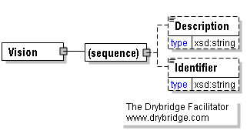
A concise and inspirational statement implicitly relating an organization's purpose to its values, thus motivating its actions toward a future state it strives to achieve.
(sequence)
The sequence of items below is mandatory. A single instance is required.
Description
Description is optional. A single instance might exist.
A sentence or short paragraph defining and explaining a concept.
Identifier
Identifier is optional. A single instance might exist.
A string of alphanumeric characters by which the information contained within an element is distinguished from other versions of the same information as well as information contained in other instances of the same element.

Weakness
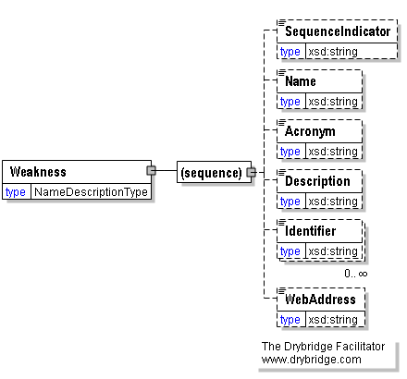
A negative aspect of an organization that may place it at a competitive disadvantage.
(sequence)
The sequence of items below is mandatory. A single instance is required.
SequenceIndicator
SequenceIndicator is optional. A single instance might exist.
An alphanumeric identifier applied to an element to designate its order in a series.
Name
Name is optional. A single instance might exist.
A word or short phrase intended to identify a concept within the context in which is it being applied.
Acronym
Acronym is optional. A single instance might exist.
An abbreviation of a proper name usually composed of the first letters of each word in the name.
Description
Description is optional. A single instance might exist.
A sentence or short paragraph defining and explaining a concept.
Identifier
Identifier is optional. Multiple instances might exist.
A string of alphanumeric characters by which the information contained within an element is distinguished from other versions of the same information as well as information contained in other instances of the same element.
WebAddress
WebAddress is optional. A single instance might exist.
The URL where the authoritative source or additional information can be found.

WebAddress
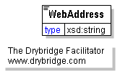
The URL where the authoritative source or additional information can be found.

Weighting [attribute]
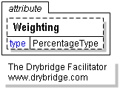
An attribute enabling the designation of a performance indicator as being a certain percentage of a total performance rating score.

Schema Level Documentation

StratMLPart3.xsd
Schema agency: ANSI AIIM Schema version: 3.0 Schema date: November 1, 2012 Disclaimer: This document and the information contained herein is provided on an "as is" basis and AIIM disclaims all warranties, express or implied, including but not limited to any warranty that the use of the information herein will not infringe any rights or any rights or any implied warranties of merchantability or fitness for a particular purpose.

